

Travlr Getaways

CS 465 Project Software Design Document
Version 1.0

Table of Contents

CS 465 Project Software Design Document 1
Table of Contents 2
Document Revision History 2
Instructions 2
Executive Summary 3
Design Constraints 3
System Architecture View 3
Component Diagram 3
Sequence Diagram 4
Class Diagram 4
API Endpoints 4
The User Interface 4

Document Revision History

Version | Date | Author | Comments
1.0 | 04/17/2026 | Zuha Asim | Added User Interface Section.

Instructions

Fill in all bracketed information on page one (the cover page), in the Document Revision History table, and below each header. Under each header, remove the bracketed prompt and write your own paragraph response covering the indicated information.

Executive Summary

The Travlr Getaways web application is designed to provide a smooth experience for both customers and administrative staff. Customers can browse and explore trips, view details, and interact with the website in a responsive and intuitive way, while administrators can manage information through a dedicated interface. The software design problem we are addressing is how to create a system that is both user-friendly and efficient, capable of handling multiple users at the same time while keeping data secure. The proposed solution divides the application into three primary components: the client, the server, and the database. This architecture ensures that each part of the system has a clear responsibility, making the application easier to maintain and scale in the future.

The application is developed using the MEAN stack, which is a popular framework for full stack development. MongoDB is used to store all customer and trip information, Express and Node.js handle server-side operations and business logic, and Angular is responsible for creating a dynamic and interactive user interface. The use of the MEAN stack allows for consistency between client-side and server-side code, efficient communication with the database, and a scalable foundation that can support future growth.

The customer-facing side of the application allows users to interact with the website to browse trips, view travel details, and interact with visual content through a web browser. The administrator interface is designed as a single-page application (SPA), which enables staff to edit information quickly without the need to reload pages. This design ensures that both customers and administrators have smooth and efficient experiences tailored to their respective needs.

Design Constraints

Developing the Travlr Getaways web application comes with certain limitations that guide how the system is built and ensure it works correctly. One important constraint is that the application must support many users at the same time. This means the server and database need to be designed to handle lots of requests without slowing down. Another constraint is the need to keep customer and administrator information secure. Users must log in safely, and the system must protect personal data from unauthorized access. The application also needs to work properly across different web browsers so that all users, no matter what device they use, can access the website without problems. Finally, the administrator interface is designed as a single-page application, which allows staff to make updates quickly but also requires careful planning to make sure the interface responds correctly to every action.

To address these constraints, the server and database will be set up to handle many requests at the same time, making sure the application stays fast and works well even when a lot of users are using it at once. Security will be handled by building a strong login system and managing user sessions, so that private information is protected and only the right people can access it. The front-end design will be tested and adjusted, so it works correctly on different web browsers, making sure that every user sees the website properly no matter what device they use. For the administrator interface, the single-page application will be planned and organized carefully so that updates happen quickly and smoothly without reloading pages, and so the client and server can communicate properly. By doing these things, the limits set by the constraints can be handled, and the application will be safe, fast, easy to use, and reliable for both customers and administrators.

System Architecture View

Component Diagram

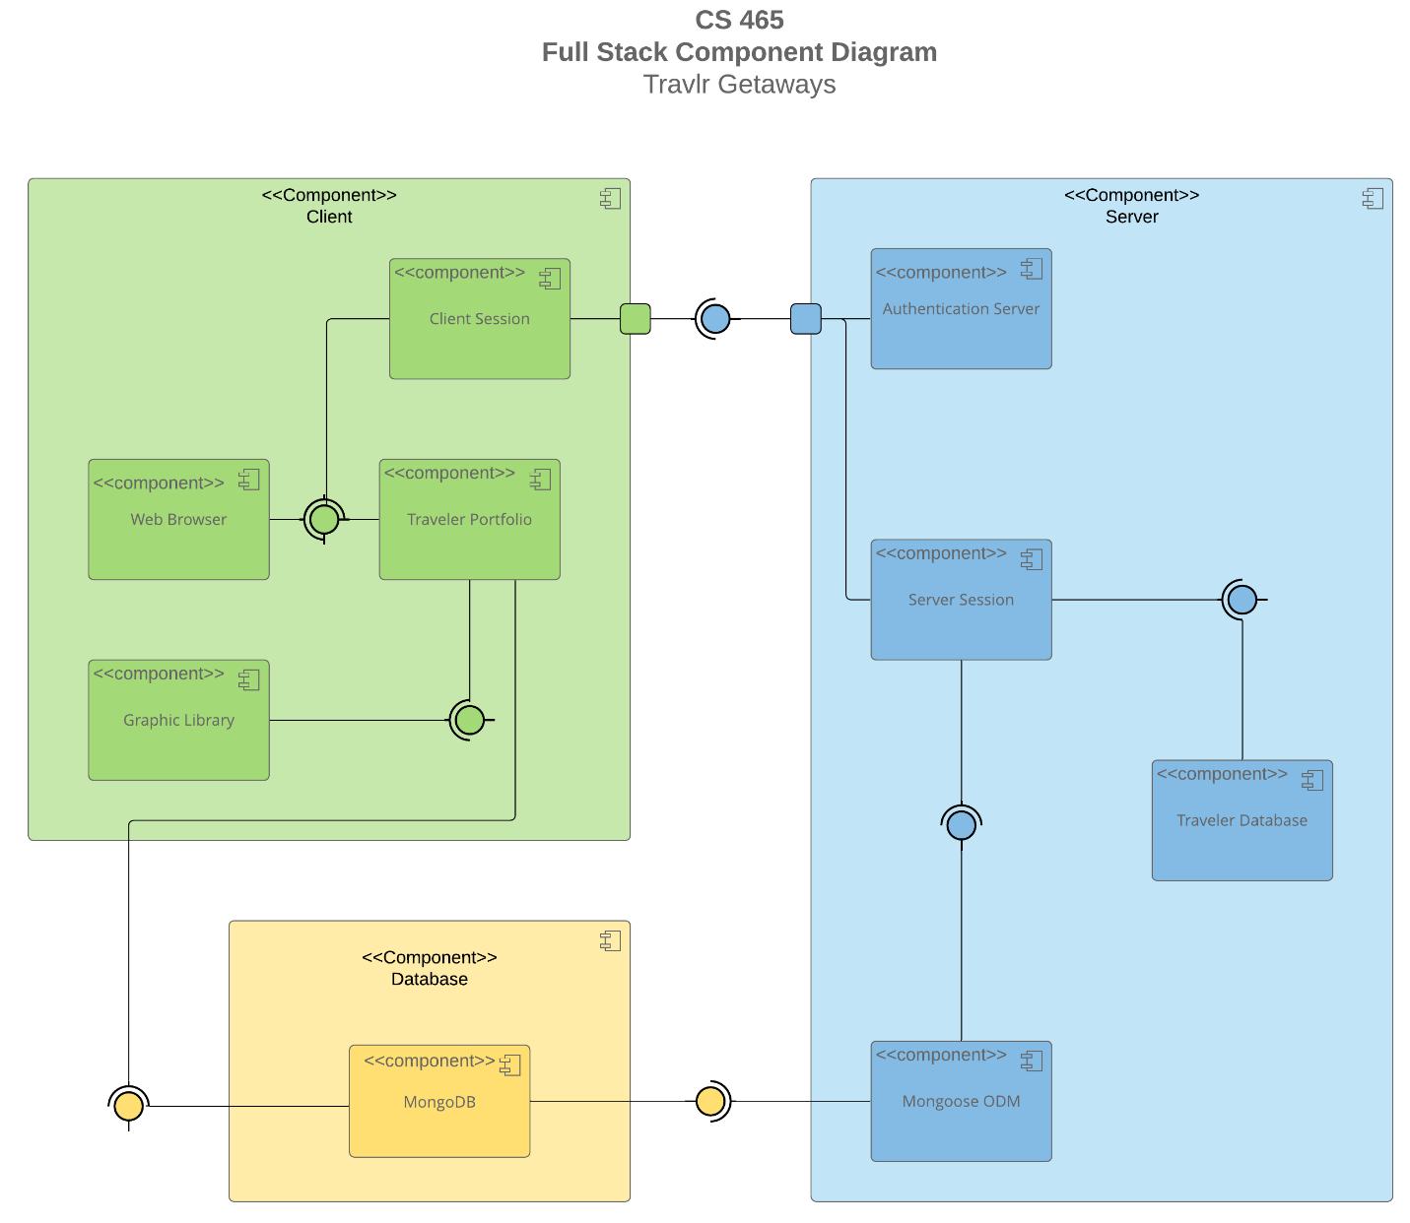

A text version of the component diagram is available: CS 465 Full Stack Component Diagram Text Version.

The Travlr Getaways web application is built around three main parts: the client, the server, and the database. Each part has a clear role and works together to make the website function smoothly. The client is what the user sees and interacts with. The server handles the application logic and makes sure the client and database can communicate properly. The database stores all the information about trips and users and shares it with the server when needed. Together, these three parts create a complete system that allows customers to browse trips easily and administrators to manage the information efficiently.

The main components in the client include the web browser, which shows the website to customers, the Client Session, which keeps track of who is logged in and manages their session information, the Traveler Portfolio, which displays trip and customer details, and the Graphic Library, which provides images and other visual content for the interface. On the server side, there is the Authentication Server, which checks user logins and protects sensitive information. The Server Session manages active user sessions, while the Traveler Database stores structured information about trips and customers. The Mongoose ODM connects the server to the database and helps the server access and update data efficiently. The database component, MongoDB, stores all the data and communicates with the server through the Mongoose ODM to provide the information the application needs.

These components are connected so they can work together. The web browser talks to the Traveler Portfolio and Client Session to show the website and keep track of the user. The Traveler Portfolio gets images from the Graphic Library and trip data from MongoDB through the server. The Server Session manages ongoing user sessions and communicates with the Traveler Database to get or update data, while the Client Session interacts with the Authentication Server to check logins. This setup creates a clear path for information to move between the client, server, and database, making the application fast, secure, and easy to use for both customers and administrators.

Sequence Diagram

The sequence diagram shows how the Travlr Getaways web application processes requests across the three main layers of the system: the client, the server, and the database. The process begins on the client side when a user navigates to a route, such as viewing trips or accessing the sign-in page. The client-side routing directs the user to the appropriate browser view or template, where the page is displayed. The controller and model then work together to handle user interactions and manage the data shown on the screen.

When a user performs an action, such as signing in, browsing trips, or an administrator updating trip information, the controller/model uses the HTTP client to send a request to the server. This request moves from the client layer to the server layer, where it is received by the routing component. The route determines which endpoint is being accessed and forwards the request to the appropriate server-side controller.

The server-side controller processes the request by applying business logic, such as validating login credentials, retrieving trip data, or updating records. To do this, it communicates with the database layer, which is powered by MongoDB. The database stores all important information, including user accounts, trip details, and administrative data, and returns the requested data to the server.
Once the server finishes processing the request, it sends a response back to the client. The controller/model on the client side receives this data and updates the view so the user can see the results immediately.

Class Diagram

The class diagram of the Travlr Getaways web application shows important JavaScript classes that work together to manage both user and trip information. Each class represents a different component of the system, with specific responsibilities and interactions between them. Below is a description of the JavaScript classes in the system:

1. TravellerInfo

This class holds information about the traveler, including essential trip data and the number of companions accompanying the traveler. It manages attributes such as totalprice, totalmiles, and stopover, representing the costs and logistical details of the trip. The TravellerInfo class also plays a role in the process of booking and managing trips as it works closely with other components like FlightInfo, HotelInfo, and CruiseInfo.

2. MemberAccount

The MemberAccount class is responsible for managing user-specific data, including their membernumber, frequent_airline, and membership status. This class plays an important role in handling the loyalty system of the application, tracking a member's frequent flyer status and the club they belong to. Methods in this class validate membership details and handle points, making it important for managing member privileges and discounts.

3. Membership_Admin

The Membership_Admin class manages all aspects related to user memberships. This includes calculating credit points based on the traveler’s itinerary, validating membership statuses, and updating the loyalty information. By interfacing with the MemberAccount class, it ensures that member privileges are respected and applied correctly during booking processes.

4. TripInfo

The TripInfo class aggregates all the essential details of a trip, including starting_date, returning_date, origin, and destination. It organizes trip-related data into one central unit, and its primary responsibility is to serve as a container for the various travel-related attributes and to ensure proper interactions with other classes such as FlightInfo.

5. CruiseInfo

This class is responsible for storing all information related to cruise bookings. It includes attributes such as the name, cabintype, and price of the cruise. The CruiseInfo class ensures that cruise-related data is properly managed and can be accessed or updated as needed during the booking process. It also supports interactions with the CruiseBooking class, which handles the actual cruise reservation.

6. FlightInfo

The FlightInfo class contains all details related to flight bookings. This includes flight name, seatclass, and price. The class is a key part of the application’s ability to handle flight-related data, interacting with both the TravellerInfo and FlightBooking classes to manage and update flight details. It ensures that users can select and modify flights as part of their itinerary.

7. HotelInfo

The HotelInfo class stores information about hotel bookings, including details like the hotel name, location, roomsrequested, and price. This class is essential for managing the accommodation aspect of a traveler’s trip. It interacts closely with both the TravellerInfo and HotelBooking classes to handle hotel reservations, ensuring the user has the right details when making bookings.

8. Itinerary

The Itinerary class represents a comprehensive collection of a traveler’s trip. It includes methods such as BookPackage, BookFlight, BookHotel, and BookCruise, which allow the traveler to book different aspects of their journey. This class consolidates the different travel components (flights, hotels, cruises) into one cohesive system and ensures that the entire itinerary is accurately created and stored.

9. Travel_Agent

The Travel_Agent class handles the booking process for travelers. It manages interactions between the traveler and various service classes like FlightBooking, HotelBooking, and CruiseBooking.

10. HotelBooking

The HotelBooking class is specifically designed to manage hotel reservations. It interacts with both the TravellerInfo and HotelInfo classes, ensuring that the correct hotel details are recorded and that the traveler’s requests are accurately reflected in the booking system. This class is crucial for managing the accommodation aspect of the trip.

11. CruiseBooking

The CruiseBooking class is dedicated to managing cruise reservations. It works similarly to the HotelBooking class but focuses on cruise-related details. By interacting with both the TravellerInfo and CruiseInfo classes, the CruiseBooking class ensures that travelers can book the correct cruises, taking into account specific details like cabin type and cruise price.

12. FlightBooking

The FlightBooking class manages flight bookings and works with both the TravellerInfo and FlightInfo classes. It ensures that flights are properly booked and that all necessary details, such as seat class and price, are reflected in the user’s itinerary. This class handles the logistics of reserving flights for the traveler and updating the relevant information in the system.

API Endpoints

Method | Purpose | URL | Notes
GET | Retrieve list of trips | /api/trips | Retrieves a list of all available trips.
GET | Retrieve a single trip | /api/trips/:tripCode | Retrieves a single trip instance, identified by the tripCode.
GET | Fetch available flight options | /api/flights | Retrieves available flight options based on the user's query.
GET | Fetch available flight detail | /api/flights/:flightCode | Retrieves details for a specific flight using the flightCode.
GET | Fetch available hotel options | /api/hotels | Retrieves available hotel options based on the user's query.
GET | Fetch a single hotel detail | /api/hotels/:hotelCode | Retrieves details for a specific hotel using the hotelCode.
GET | Fetch available cruise options | /api/cruises | Retrieves available cruise options based on the user's query.
GET | Fetch a single cruise detail | /api/cruises/:cruiseCode | Retrieves details for a specific cruise using the cruiseCode.
GET | Fetch traveler’s account details | /api/member/:memberId | Retrieves information about the traveler by their member ID.
POST | Create a new trip booking | /api/trip/book | Submits the details of a new trip booking.
POST | Create a new member account | /api/member/register | Registers a new traveler as a member.
POST | Validate membership status | /api/member/validate | Checks the traveler’s membership validity.
POST | Book a flight | /api/flight/book | Submits a flight booking request.
POST | Book a hotel | /api/hotel/book | Submits a hotel booking request.
POST | Book a cruise | /api/cruise/book | Submits a cruise booking request.
PUT | Update a trip | /api/trips/:tripCode | Updates the details of a single trip instance, identified by the tripCode.
PUT | Update a flight | /api/flight/book/:flightCode | Updates flight booking details for a specific flight using the flightCode.
PUT | Update a hotel | /api/hotel/book/:hotelCode | Updates hotel booking details for a specific hotel using the hotelCode.
PUT | Update a cruise | /api/cruise/book/:cruiseCode | Updates cruise booking details for a specific cruise using the cruiseCode.
DELETE | Cancel a trip | /api/trips/:tripCode | Cancels a trip booking using the tripCode.
DELETE | Cancel a flight booking | /api/flight/book/:flightCode | Cancels a flight booking using the flightCode.
DELETE | Cancel a hotel booking | /api/hotel/book/:hotelCode | Cancels a hotel booking using the hotelCode.
DELETE | Cancel a cruise booking | /api/cruise/book/:cruiseCode | Cancels a cruise booking using the cruiseCode.

The User Interface

A Unique trip

The Edit Screen

The Update Screen

The Angular project structure represents a significant shift from the Express project structure used in the initial phases of the Travlr Getaways application. While the Express side is built on a file-based architecture using Handlebars templates and middleware routes to serve server-rendered pages, Angular utilizes a component-based architecture. This organizes the application into distinct modules, components, and services using TypeScript, which provides a sturdy development environment. This separation of concerns in Angular allows for highly reusable UI elements and a cleaner division between the presentation layer and the logic, compared to the simpler, template-driven approach of Express.

The administrator interface is designed as a Single-Page Application which provides a much richer and more responsive user experience compared to a traditional web application interaction. In a simple web application, every user action typically requires the browser to request and reload an entirely new page from the server which leads to noticeable latency. In contrast, the Travlr SPA updates the view dynamically by swapping only the necessary components without a full-page refresh. By leveraging asynchronous data exchange, the application can fetch data in the background while the interface remains interactive. This architecture creates a fluid and app-like feel that supports more complex interactions and real-time data updates on the client side which significantly improves the overall efficiency and speed of administrative tasks.

The process of testing the SPA to ensure it communicated effectively with the API for GET and PUT operations involved several integrated verification steps to ensure data integrity across the full stack. To ensure GET requests were correctly retrieving data, I monitored the user interface to confirm that trip details were successfully pulled from the MongoDB database and rendered correctly within the Angular components. I also utilized browser developer tools and console logs to trace the JSON payloads moving through the system. To test PUT functionality, I used the specialized Edit and Update screens to modify trip records and then verified that these changes were accurately persisted in the database by cross-referencing the records in MongoDB Compass. This process was further validated by utilizing Postman to independently test the API endpoints which allowed me to verify that the backend returned the correct HTTP status codes and maintained data integrity throughout every interaction. In conclusion, the transition to an Angular-based SPA architecture successfully provided a highly efficient, interactive interface that communicates reliably with the backend API to manage travel data.

